Expect to be checked!

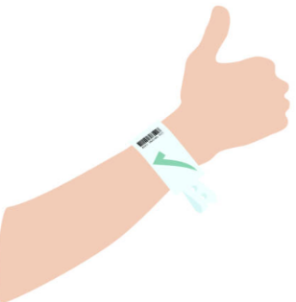
- Expect that an identification
wristband will be placed
on your wrist

- Expect that we will check
your identification wristband
every time we perform a
treatment, procedure, give
medication or collect a
specimen

- Expect to be asked your
first name, second name
and date of birth

- Expect that if you are
moving wards or brought
for an in house procedure
we will check your wrist band

