Department Name | Heart Efficiency Service  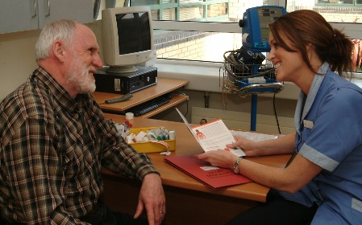
Overview | Heart failure or ‘heart inefficiency’ means that your heart muscle is not pumping as efficiently as it should.  There are two kinds of heart inefficiency. One is where the heart cannot pump as well as it should. The other type is when the heart is stiffer than normal so it cannot relax as it should.  The primary goals of treating patients with heart failure are:  - To decrease the likelihood of disease progression;  - To lessen symptoms;  - To improve the quality of life for the patient;  - Reduce readmissions to hospital.
What we do? | The Heart Efficiency Service is a specialised nurse led service established with the aim of improving the health and well-being of patients who have been told that they have heart failure.  The service is managed by Heart Efficiency Nurse Specialists who are responsible for providing expert nursing care, which includes working as an educator, health promoter and patient advocate. The Heart Efficiency Nurses work with the multidisciplinary team to empower patients to manage their heart failure condition in order to alleviate symptoms and optimise their quality of life. Members of the patient's family are welcomed and play a crucial part in the holistic delivery of care.  Following establishment of the service in 2003 it has demonstrated a positive impact on preventing hospital admissions, improved assessment and management of patients and ultimately improved quality of life for our patients with heart failure.
Contact Details | The Heart Efficiency Service is a service provided by the Cardiology Department. Our telephone number is: 01 – 414 3136 and Fax: 01 414 2168  Our Consultant Cardiologists are:  Dr Vincent Maher  Dr David Moore  Dr David Mulcahy  Dr Bryan Loo  Clinical Nurse Specialists:  Sarah Fall  Michelle Carey  Tara Mannion
What to expect? | Whether you are coming to Tallaght Hospital from around the corner or from further afield, we want you to know what to expect before, during and after your visit.  If you have any questions while reviewing this information, please contact us on 01 – 414 3136.  What will I need to bring with me to my appointment?  - You will need to bring your list of tablets with you as you currently take them.  - Alternatively, bring all the medications or blister pack with you.  - Take them as usual before your visit.  - If you are on a water tablet you may hold off taking this particular tablet until you arrive home after your appointment unless otherwise directed.  - Bring a record of your daily weights which will be reviewed at each clinic visit.  Please have your blood tests done in Tallaght Hospital within 2-3 days of your appointment as it helps with your assessment. This can be done in Phlebotomy department on the ground floor before 4pm Monday to Friday.  What will I expect during my appointment?  Your first visit may take up to two hours. Please ensure that you have a relative/carer with you if you need assistance in any way.  You will be assessed by a Clinical Nurse Specialist and a Doctor if required.  See attached leaflets for further information.
General Advice | - Take an active role in the management of your condition  - Enlist the help of a family member or friend  - Know your medications  - Ensure you take your medications as directed  - Weigh yourself every morning as instructed and keep a record of readings in the weight book that we provide  - Inform your doctor or nurse specialist about any significant weight gains. (2kgs or 4lbs in two days with symptoms should be reported)  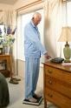  - Exercise wisely and rest during the day  - Ask your GP about vaccinations  - Keep in contact with your GP and/or nurse specialist, pharmacist and dietitian, and do not hesitate to ask questions  - Recognise the signs of deterioration in your condition and contact help immediately  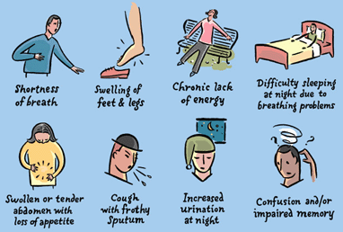  How much fluid can I drink?  You need to drink at least one litre of all fluids – tea, coffee, water, juices. Most stable patients are allowed to drink 1.5 to 2 litres a day.  What about alcohol?  Alcohol if desired should be taken in moderate amounts. In some cases where alcohol has damaged the heart muscle, it is best avoided and this should be discussed with your Doctor or Nurse Specialist in more detail.  Remember that this volume must be included as part of your fluid allowance.  Do I need to change my diet?  Salt can interact with some of your medication and cause you to retain fluid. Table salt should be avoided and taken off the table.  Alternative seasonings such as pepper, lemon, onion, garlic, fresh/dried herbs can be used.  "Salt Substitutes" are not suitable alternatives to salt. Fresh fruit and vegetables should play a large role in the diet.  How much physical activity can I do?  It is important to balance periods of activity with periods of rest. Towards the end of your visits with us we may refer you to an eight week exercise programme.  Advice during periods of flu like symptoms:  - Rest and take it easy.  - Ensure that you are adequately hydrated as directed by your nurse specialist.  - If you are not able to drink adequate fluids or have symptoms of vomiting or diarrhoea seek advice from your GP or nurse specialist.
Useful links  Patient Information Leaflets: | http://www.irishheart.ie/iopen24/heart-failure-t-7_19_63.html  http://www.irishheart.ie/iopen24/pub/patient_booklets/living_with_heart_failure.pdf  http://www.heartfailurematters.org/en_GB  Patient Information Leaflet  How to manage and monitor my condition?

